**Experiment No.: 5 Date 13-03-2023**

**AIM**: Familiarization of linux commands.

**CO2**: Perform system administration task.

**Procedure:**

1. read : read a line

$read

$ echo $REPLY

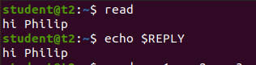

1.1. Read into variables

$ read var1 var2 var 3

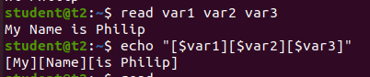

1.2 read multiple lines using backslash

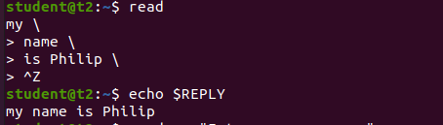

1.3 $read -p : Prompt something in the screen

$read -p “something ”

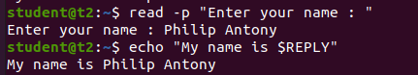

1.4 $read - n: read only a specific length of characters

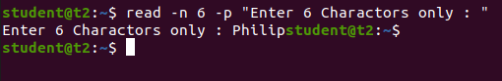

1.5 $read -s : read secure data like passwords

$read -s -p “Enter password”

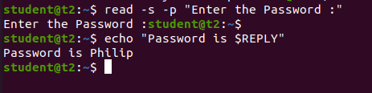

2. $wc filename: display the details of file

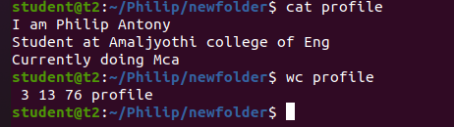

2.1 $wc -l : To display number of lines

$wc -l profile



2.2 $wc -m : To display number of bytes

$wc -m profile



2.3 $wc -c : To display number of characters

$wc -c profile



2.4 $wc -w: To display number of words

$wc -w profile



2.5 $wc -L : Length of the longest line

$wc -l profile



2.6 $more : command is used to view the text files in the command prompt, displaying one screen at a time in case the file is large

$more myfile.txt

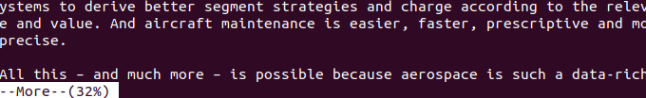

2.7 $more +4: type the number of lines that you want to display per screen.

$more +4 myfile.txt

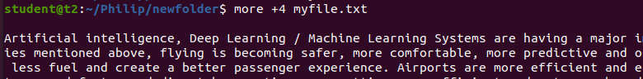

2.8 $more +/something : Search the pattern string

$more +/Deep myfile.txt

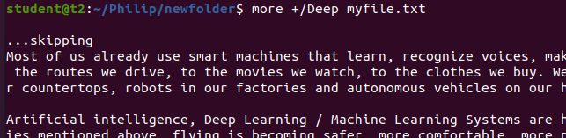

2.9 $more -d:help user to navigate , press space to continue, q to quit

$more -d myfile.txt

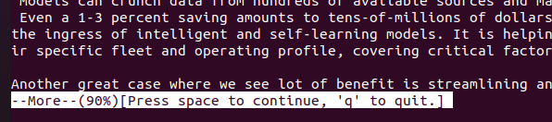

**Result**

The program was executed and the result was successfully obtained. Thus CO2 was obtained